HANU Training Management System

Use-Case-Realization Specification: View Grade (Student)

Version 1.0

*[Note: The following template is provided for use with the Rational Unified Process. Text enclosed in square brackets and displayed in blue italics (style=InfoBlue) is included to provide guidance to the author and should be deleted before publishing the document. A paragraph entered following this style will automatically be set to normal (style=Body Text).]*

*[To customize automatic fields in Microsoft Word (which display a gray background when selected), select File>Properties and replace the Title, Subject and Company fields with the appropriate information for this document. After closing the dialog, automatic fields may be updated throughout the document by selecting Edit>Select All (or Ctrl-A) and pressing F9, or simply click on the field and press F9. This must be done separately for Headers and Footers. Alt-F9 will toggle between displaying the field names and the field contents. See Word help for more information on working with fields.]*

Revision History

| **Date** | **Version** | **Description** | **Author** |
| --- | --- | --- | --- |
| 06/12/2021 | 1.0 | Final | Nguyễn Thị Thu Hiền |
|  |  |  |  |
|  |  |  |  |
|  |  |  |  |

Table of Contents

1. Introduction 4

1.1 Purpose 4

1.2 Scope 4

1.3 Definitions, Acronyms, and Abbreviations 4

1.4 References 4

1.5 Overview 4

2. Flow of Events—Design 5

3. Derived Requirements 5

Use-Case-Realization Specification: View Grade (Student)

# Introduction

## Purpose

This Use-case Realization Specification describes how the use-case View Grades (Student) is realized in terms of cooperating objects in the design model.

## Scope

This document is solely related to View Grades (Student) use case.

## Definitions, Acronyms, and Abbreviations

none

## References

[1] **Use-case Specification: View Grades (Student)**, Nguyễn Thị Thu Hiền, December 05, 2021, HANU’s Training Management.

[2] Class Diagram: <https://app.diagrams.net/#G1ktXyro25JJ60rXaYjkn01-Bh4JUzT1Ws> were done by Nguyễn Thị Thu Hiền.

## Overview

The Use-Case Realization Specification of the View Grade (Student) Use-Case of the HANU's Training Management is detailed in the next section. The Use-Case definition is described in text form in the first section. The diagrams (sequence and class diagrams) in the next section describe how the use case is realized in terms of collaborating objects.

# Flow of Events—Design

## Summary

This use-case involves using four types of objects: GradePage, GradeController, Grade and GradeData.

## Class diagram

**2.2.1 Overview:**

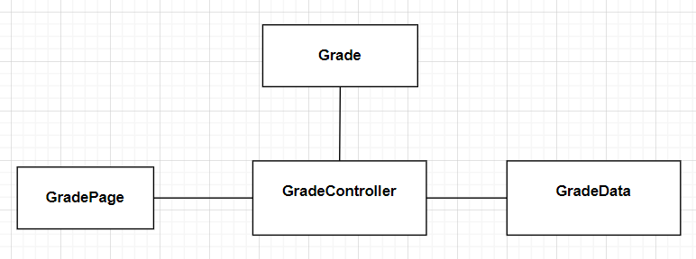

**2.2.2 Details:**

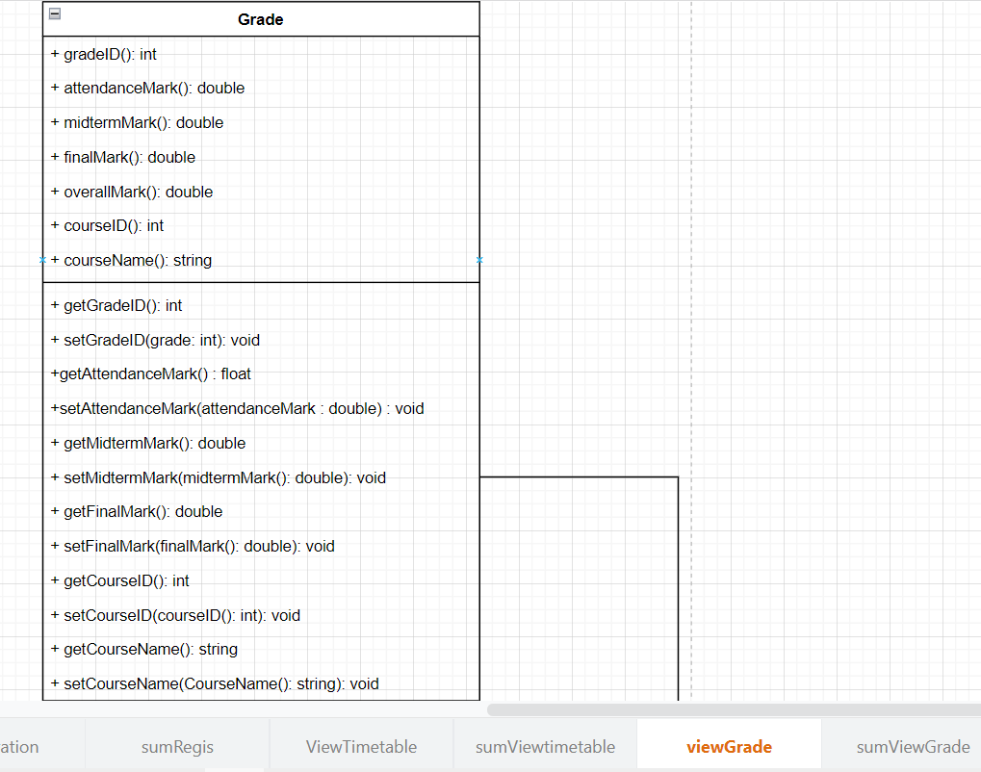

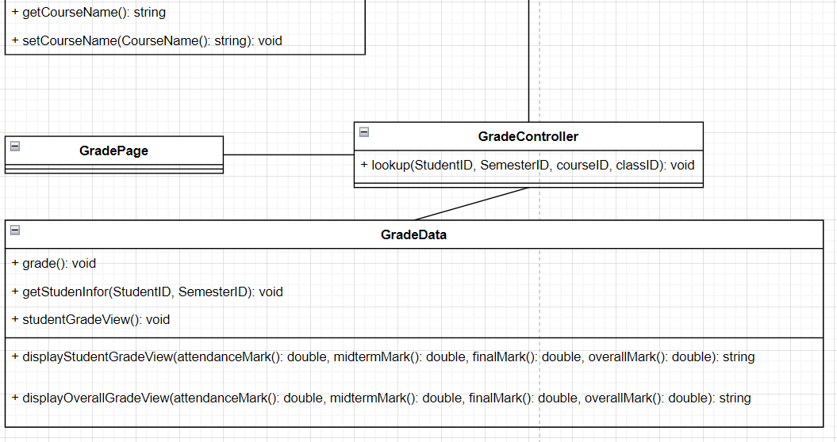

* 1. **Sequence diagram**

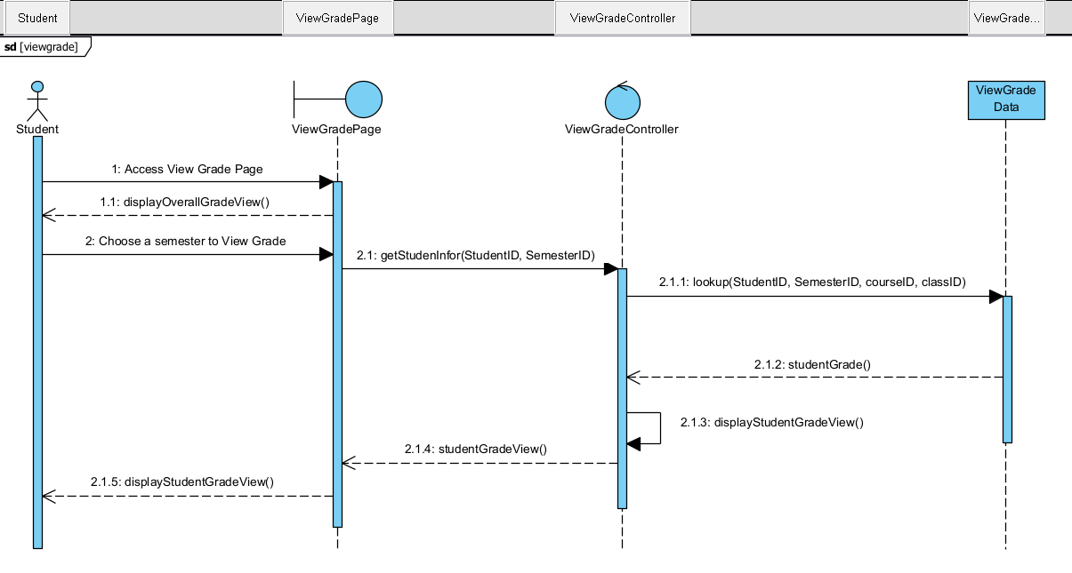

# Derived Requirements

* Display manner: The StudentGradesView should display the grades lines that differ according to the status of each (No mark yet, Passed, Failed).